CURTIN ISAD 3000 · PROJECT PORTAL
Release Notes
Curtin ISAD 3000 Project Portal
Project | Curtin ISAD 3000 Project Portal
Document ID | CP-RN-001
Version | 1.2
Date | 25 October 2026
Author | Darren
Status | Draft for review
Classification | Internal

What changed in the 23-25 October 2026 updates of the Curtin ISAD 3000 Project Portal: Sign in and Create account tabs, lecturer-managed Lessons & Videos with uploads, a one-time maintenance notice and quality checks.

Document Control

Document information
Document title | Release Notes
Document ID | CP-RN-001
Project | Curtin ISAD 3000 Project Portal
Document type | Release notes and change summary
Version | 1.2
Author | Darren
Date issued | 25 October 2026
Status | Draft for review
Classification | Internal
Intended audience | Project owner, lecturers, administrators

Revision history
Version | Date | Author | Description of change
1.0 | 23 October 2026 | Darren | First issue for the 23 October 2026 maintenance update.
1.1 | 23 October 2026 | Darren | Lecturer-managed lessons and role choice at sign-in.
1.2 | 25 October 2026 | Darren | Reissued for the account change: Sign in and Create account tabs, role stored with the account, approved lecturers.

Review and approval
Role | Name | Signature | Date
Author | Darren |  | 25 October 2026
Reviewer
Approver

Related documents
Document ID | Title
CP-SRS-001 | Software Requirements Specification
CP-UAT-001 | User Acceptance Testing (UAT) Document
CP-UG-001 | User Guide
CP-LG-001 | Login Guide

1. Release summary
Item | Detail
Release | Updates of 23 and 25 October 2026 (document version 1.2)
Portal address | https://capstone-portal-test.tranphucdang0709.workers.dev/
Headline changes | Lessons & Videos managed by lecturers (documents, video files, YouTube links); Sign in / Create account tabs (role belongs to the account); one-time maintenance notice; sender address for sign-in emails; new integrity test
Unchanged | Emailed 6-digit code sign-in, 8-hour session, approved-email list, the 2,500-project directory (search, filters, details)
Action needed from users | New users: use Create account once, then Sign in. Lecturers: your email must be approved. Everyone: a short notice appears once.

2. What is new

2.1 Sign in and Create account
The sign-in page now has two tabs. Sign in is for people who already have an account. Create account is for first-time users: name (optional), email and account type (Student by default, or Lecturer). The role is stored with the account, so nobody picks a role at each sign-in any more.
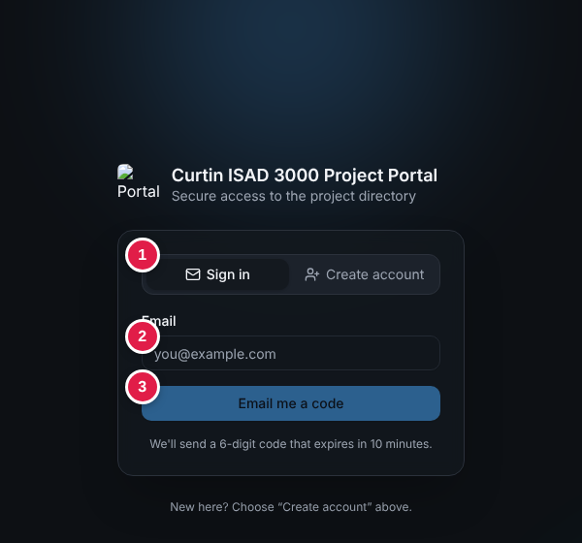
Sign in tab: (1) tabs, (2) email, (3) Email me a code
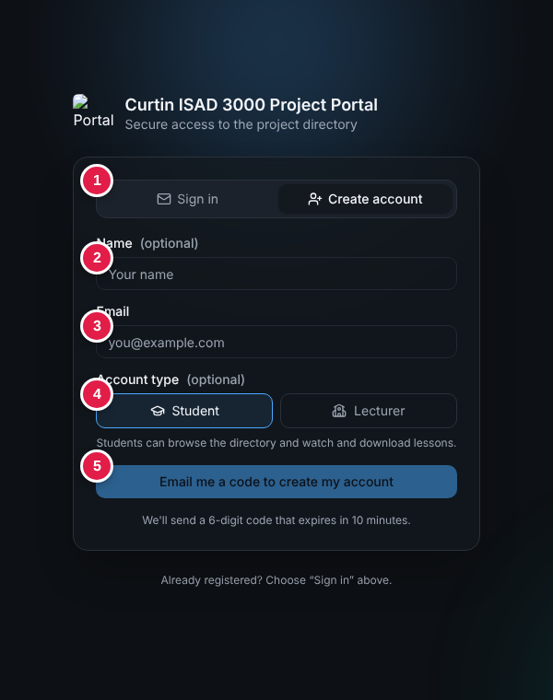
Create account tab: (1) tabs, (2) name, (3) email, (4) account type, (5) button
Situation | What happens
Sign in with an email that has no account | "No account found for that email. Create an account first." and the page switches to Create account.
Create account with an email that already has one | "An account with this email already exists. Sign in instead." and the page switches to Sign in.
Create account as Student | "Account created. Welcome!" and the user is signed in.
Create account as Lecturer with an approved email | Account created with the Lecturer role (approved = listed as Lecturer in the user list or in LECTURER_EMAILS).
Create account as Lecturer with an email that is not approved | Account created as a Student, with a notice: "Lecturer access needs approval. Ask the portal owner to add your email as a lecturer."
Database cannot be written | "Could not save the account (database is read-only). Set DATABASE_URL on the server."
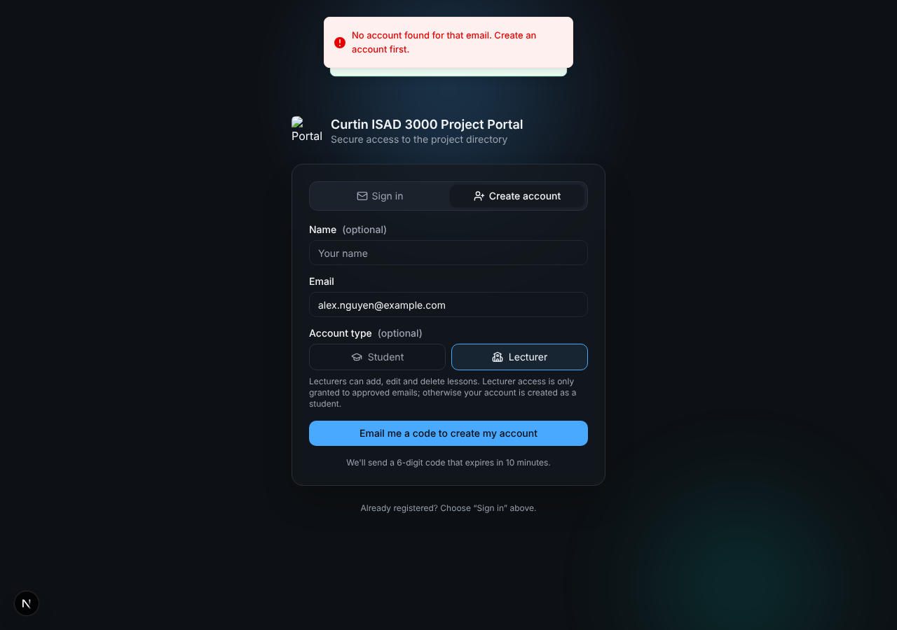
Signing in without an account
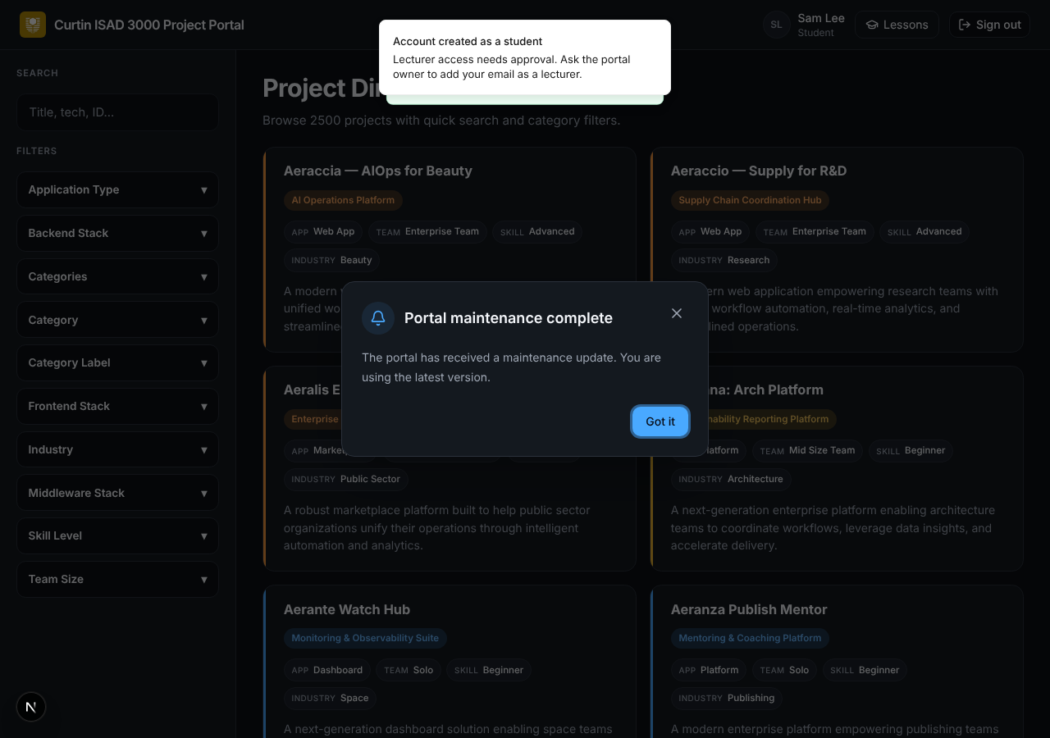
Lecturer request without approval: created as a student

2.2 Lessons & Videos
A Lessons button in the top bar opens the lessons page. Everyone who is signed in can search, watch and download. Lessons are stored by the Portal, so lecturers can keep adding material without a new release.
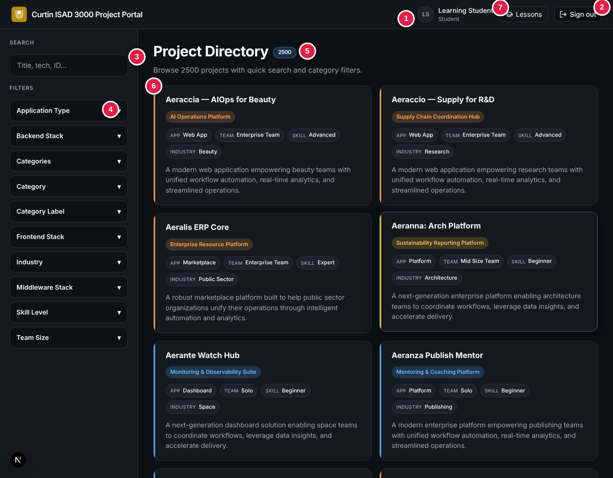
Project directory with the new Lessons button (7) in the header
For | Capabilities
Students | Search lessons (title, description, section); filter by section; Watch or Open a lesson; play an uploaded video (seeking works) or a YouTube video; Download documents; Hide; Back to directory.
Lecturers | Everything students can do, plus Add lesson and a trash button to delete a lesson.
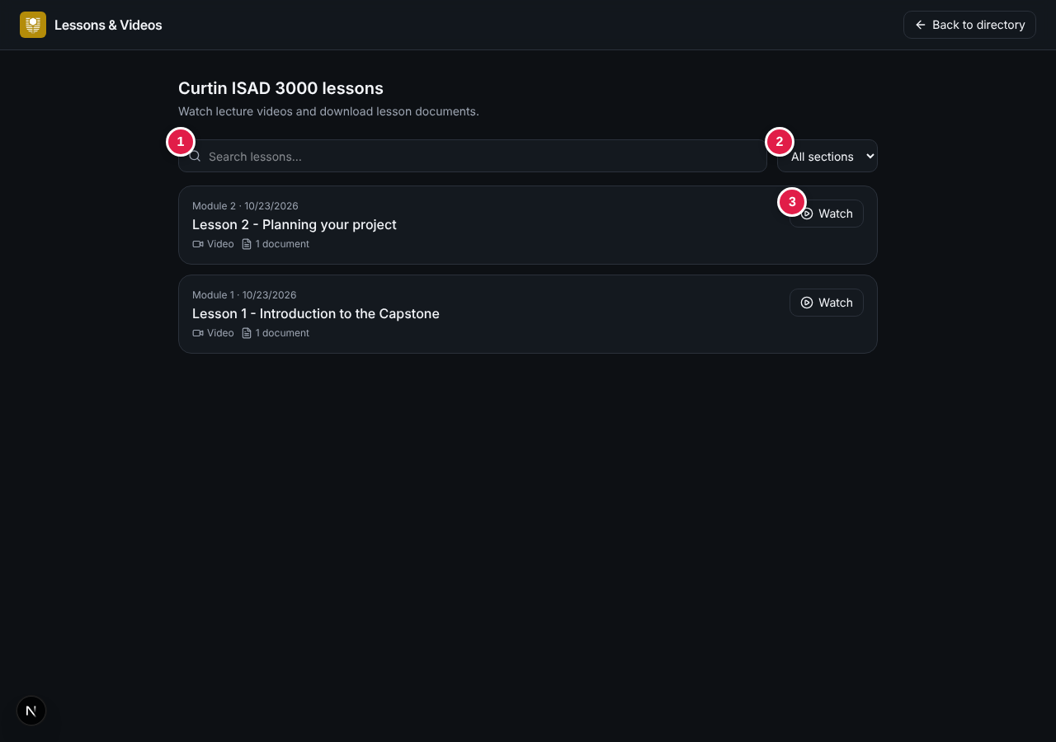
Lessons page for a student: (1) search, (2) section list, (3) Watch
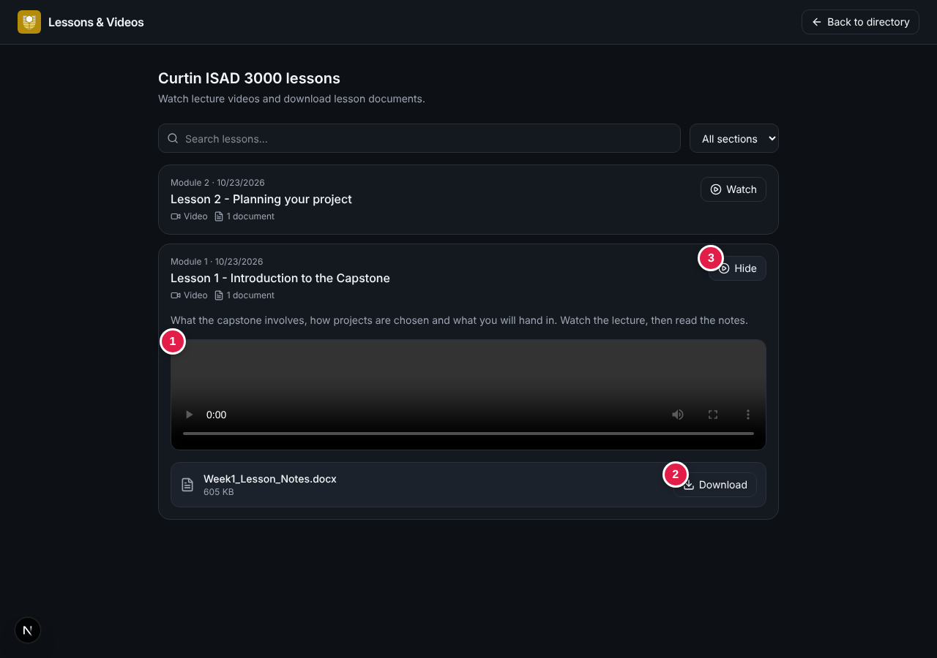
Open lesson: (1) video, (2) Download, (3) Hide

Adding a lesson (lecturers)
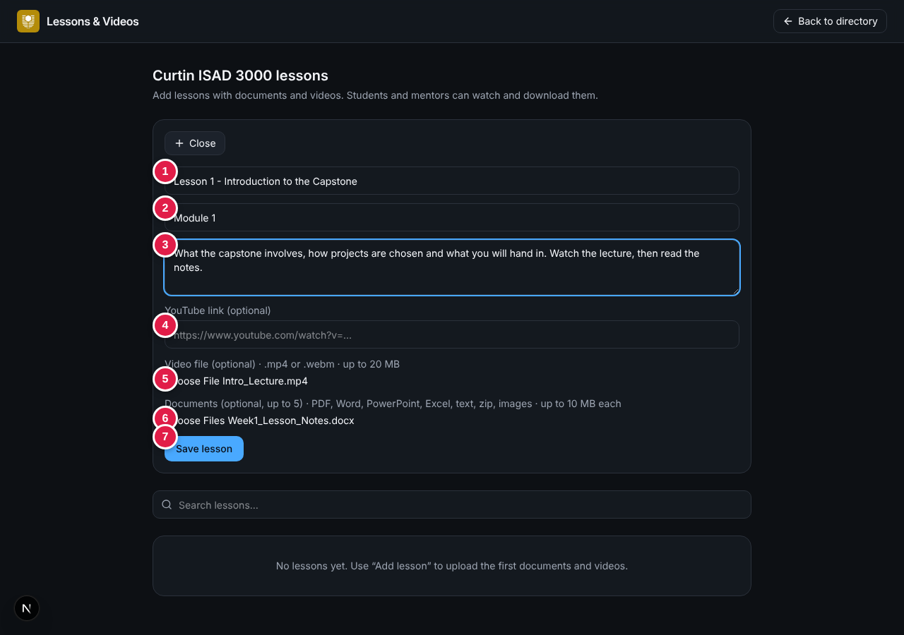
Add lesson form: (1) title, (2) section, (3) description, (4) YouTube link, (5) video file, (6) documents, (7) Save lesson
Field | Rule
Title | Required, up to 160 characters
Section / module, description | Optional (80 and 2,000 characters)
YouTube link | Optional; watch, youtu.be, embed or shorts links, or an 11-character id
Video file | Optional; one .mp4 or .webm up to 20 MB
Documents | Optional; up to 5 files of 10 MB: PDF, Word, PowerPoint, Excel, text, Markdown, zip, PNG, JPEG
Required overall | A title and at least one document, video file or YouTube link
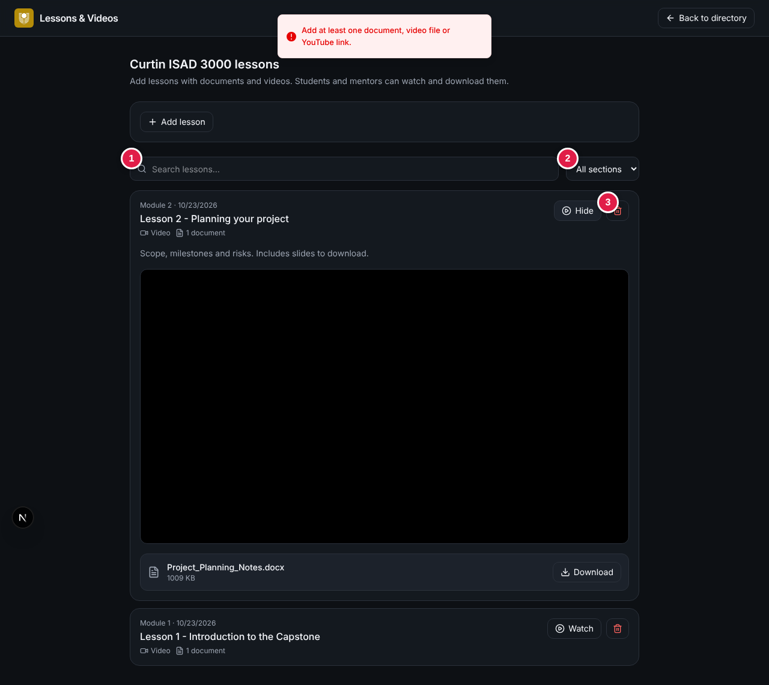
Lecturer view: (1) search, (2) section list, (3) delete
WARNING
Uploaded files are stored in the database. On a hosted deployment a writable libSQL / Turso database must be configured, or uploads cannot be saved (the Portal shows a hint).

2.3 Maintenance notice
After signing in, users see a short dialog that the Portal has been updated. It appears once per person for each notice. Administrators change the wording by editing one data file (see CP-DAG-001, section 5).
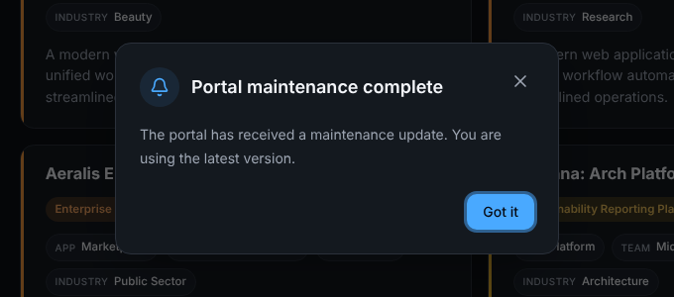
Maintenance notice shown after sign-in

2.4 Other changes
Area | Change
Sign-in email | Default sender is "Capstone Portal <no-reply@alionova.online>".
Quality | New automated test checks the maintenance-notice file; existing checks remain.
Documentation | README gains a "Maintenance notifications" section.
Settings | New optional setting LECTURER_EMAILS: emails that may create Lecturer accounts.
Removed | The fixed list of 90 course modules and bundled lesson documents is no longer part of the Portal; lessons now start empty and are added by lecturers.

3. Verification checklist
ID | Check | Expected result | Pass?
RN-01 | Sign-in page: look at the tabs. | Sign in (selected) and Create account.
RN-02 | Sign in as murphy.choy@icloud.com. | Signed in; header shows role Lecturer without choosing a role.
RN-03 | Create an account with a new email choosing Lecturer (not approved). | Account created as Student with the approval notice.
RN-03b | Sign in with an email that has no account. | "No account found..." and the Create account tab opens.
RN-04 | Create a student account; read and dismiss the notice. | Notice appears once; Got it closes it for good.
RN-05 | Student opens Lessons. | No Add lesson or trash buttons.
RN-06 | Lecturer: Add lesson with a video file and a document. | "Lesson added."; lesson listed first.
RN-07 | Lecturer: add a lesson with only a title. | "Add at least one document, video file or YouTube link."
RN-08 | Student: search, open the lesson, play the video, drag the bar. | Video plays and seeks.
RN-09 | Student: Download the document. | File downloads and opens.
RN-10 | Lecturer: delete the test lesson and confirm. | "Lesson deleted."; it disappears for students too.
RN-11 | Open /lessons while signed out. | Redirected to the sign-in page.

4. Known issues and recommendations
No. | Item | Recommendation
1 | The logo image does not show on the sign-in page for signed-out visitors (the route guard also blocks /logo.png). | Exclude the logo path in proxy.ts.
2 | .env.example contains a realistic SESSION_SECRET. | Replace with a placeholder and rotate the live secret.
3 | README still describes an older password sign-in in places. | Update it to the emailed-code flow.
4 | The Lecturer note says lecturers can "edit" lessons, but only add and delete exist. | Add an edit function or change the wording.
4b | Anyone with an approved email can create an account; a mistaken account type cannot be changed in the Portal. | Add a way for administrators to change roles, or edit the user list.
5 | Videos are stored inside the database (up to 20 MB each), which can grow quickly. | Prefer YouTube links for long videos; consider object storage later.
6 | The notice is remembered per browser, not per account across devices. | Store dismissals with the account if needed.
7 | The lecturer "Upload" link and /admin page (project upload) remain in the code although the Portal is described as having no project upload. | Remove them if not wanted.

